Dilay Selim Multimedia and Web Design
Portfolio-Website Explanation

- Navigation Bar (header)
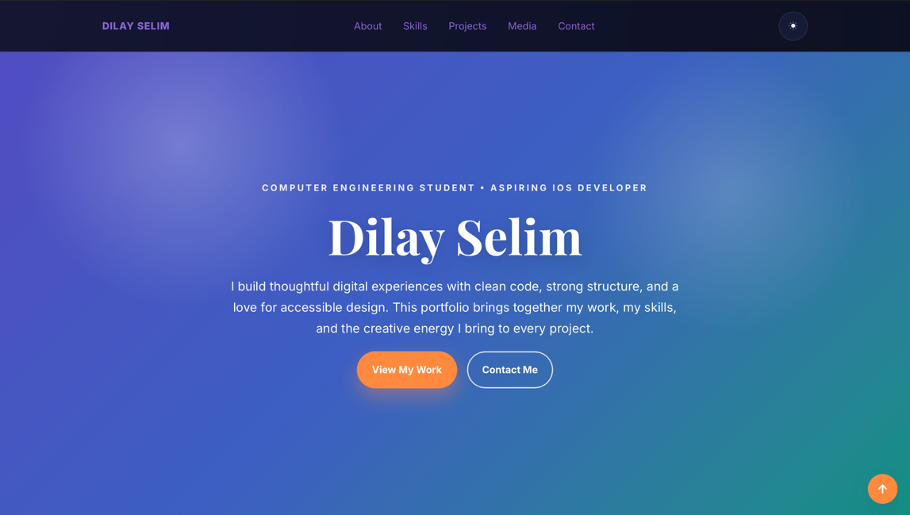

- The navigation bar appears at the top of the website and allows users to easily move between sections such as About, Skills, Projects, Media, and Contact. It was created using semantic HTML elements like <header> and <nav>. CSS Flexbox was used to align the menu items horizontally and create spacing. A theme toggle button was also implemented using JavaScript to switch between light and dark modes.

Hero Section (Landing Section)
The hero section is the first area users see when opening the website. It introduces the portfolio owner with a large title and short description. It includes two call‑to‑action buttons: 'View My Work' and 'Contact Me'. This section was built using semantic HTML (<section>) and styled with CSS gradients, typography, and spacing to create a visually appealing introduction.

About Me Section
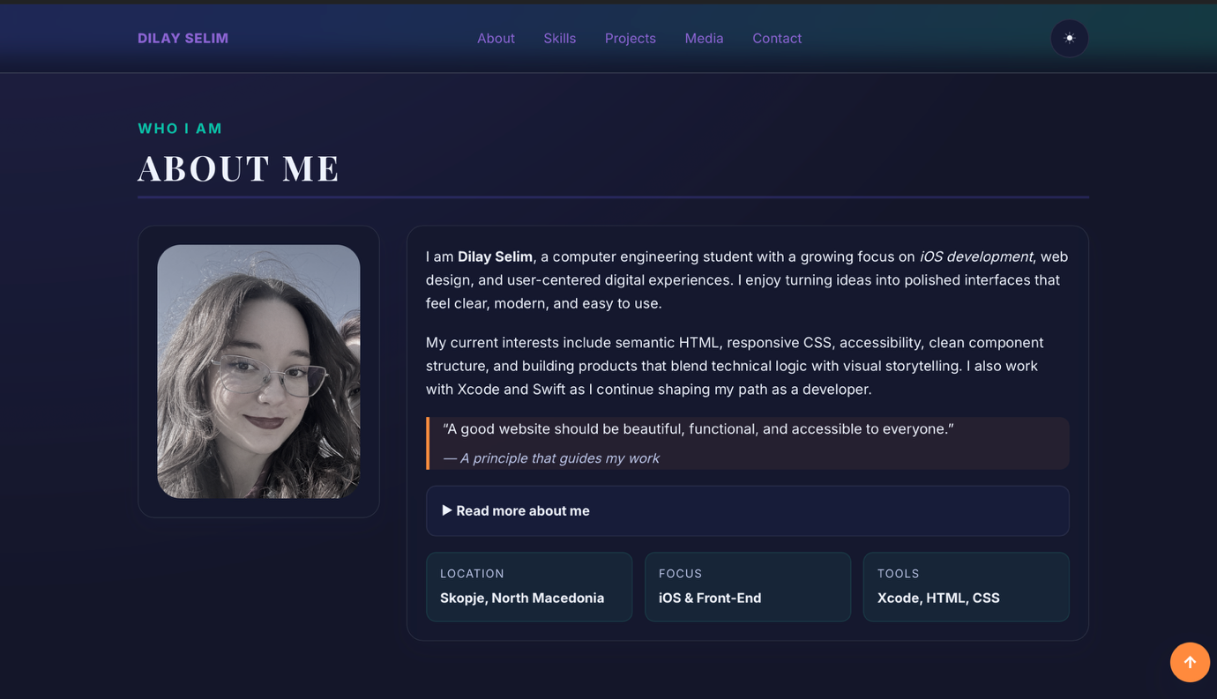

- The About section provides personal information about the developer and their interests. It contains a profile image, descriptive paragraphs, and a quote about web design principles. This section was built using HTML elements such as <figure>, <img>, <p>, and <blockquote>. CSS Grid/Flexbox was used to create a responsive layout where the image and text align nicely.

Skills and Learning Journey
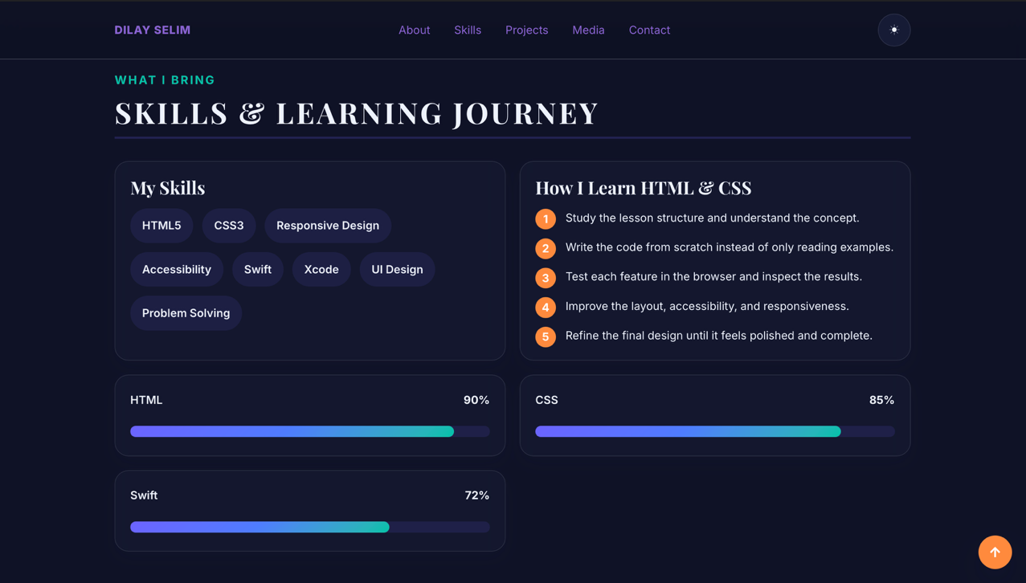

- This section highlights technical skills and the process used to learn HTML and CSS. A list of skills such as HTML5, CSS3, Swift, Accessibility, and Responsive Design is displayed using styled tags. The learning steps are presented in an ordered list (<ol>). Progress bars were implemented using the HTML <progress> element and styled with CSS to visually show skill levels.

Projects Section
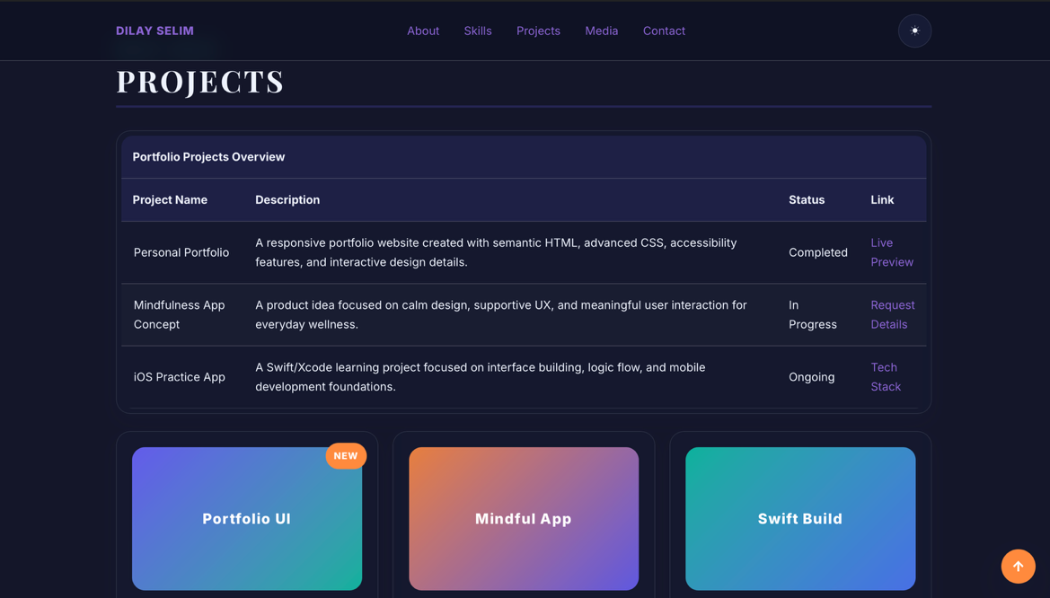

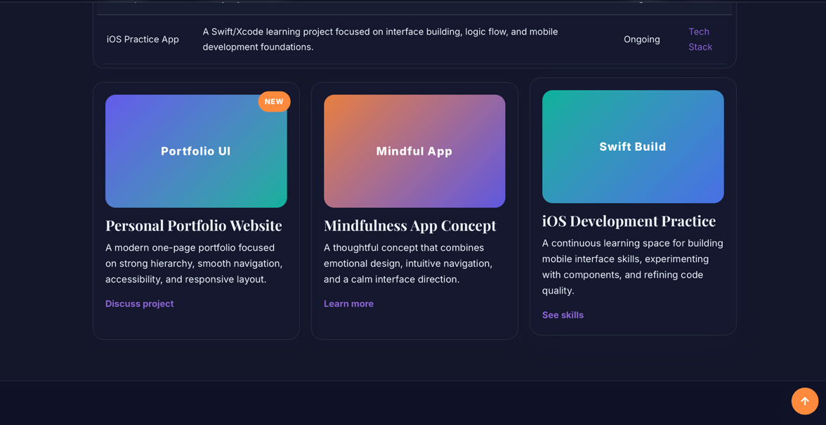

- The Projects section showcases example projects and development work. It includes a table summarizing project information such as name, description, status, and links. Below the table, project cards visually present each project using CSS cards and gradient backgrounds. This section demonstrates the use of HTML tables, semantic structure, and modern CSS layout techniques.

Media and Work Section
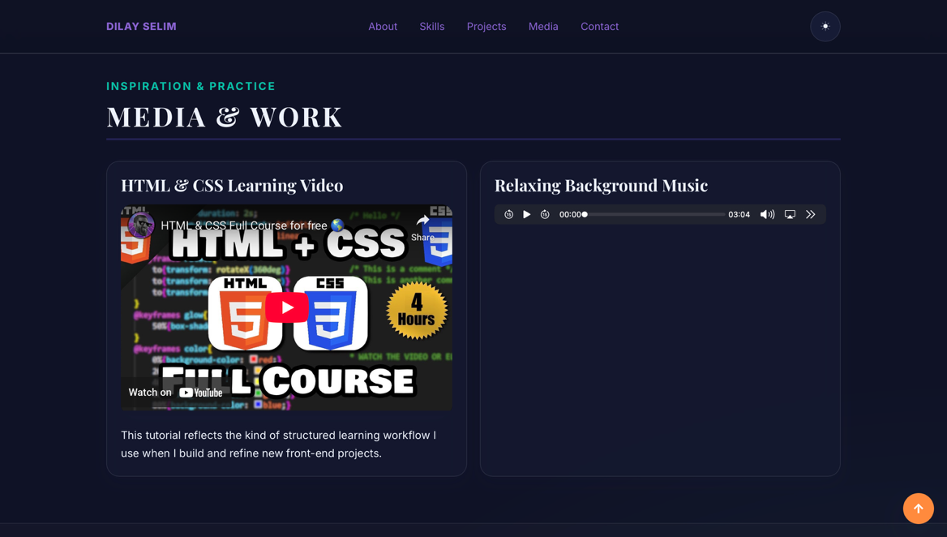
- This multimedia section demonstrates the use of embedded media. A YouTube video is embedded using the <iframe> element to show an HTML and CSS tutorial. An audio player is implemented using the HTML5 <audio> element with an MP3 file. This demonstrates the use of multimedia elements required for modern web design.

6. Contact Section

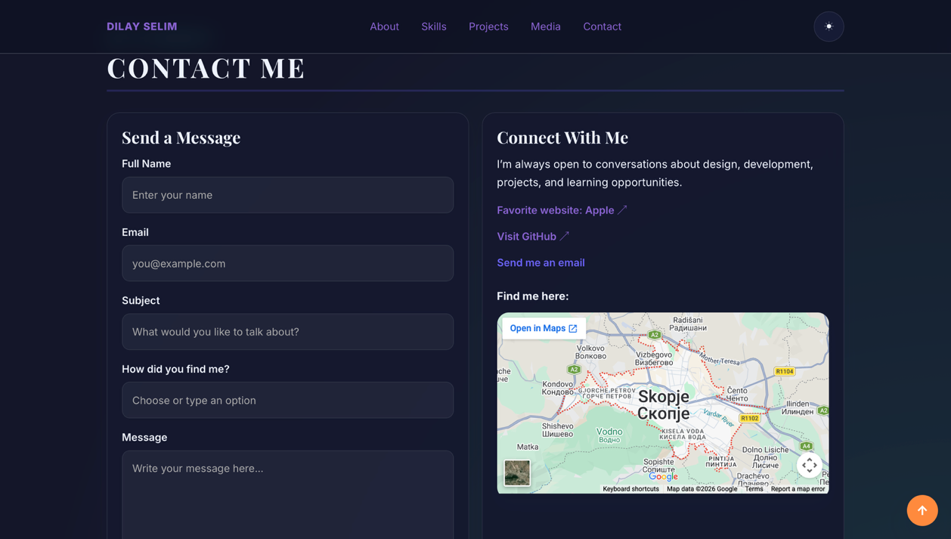

- The contact section allows visitors to send messages and connect with the developer. A contact form was created using HTML form elements including <input>, <textarea>, and <datalist>. Additional links such as GitHub, favorite websites, and email are provided. A Google Maps embed is included using an iframe to display the location.

7.Footer
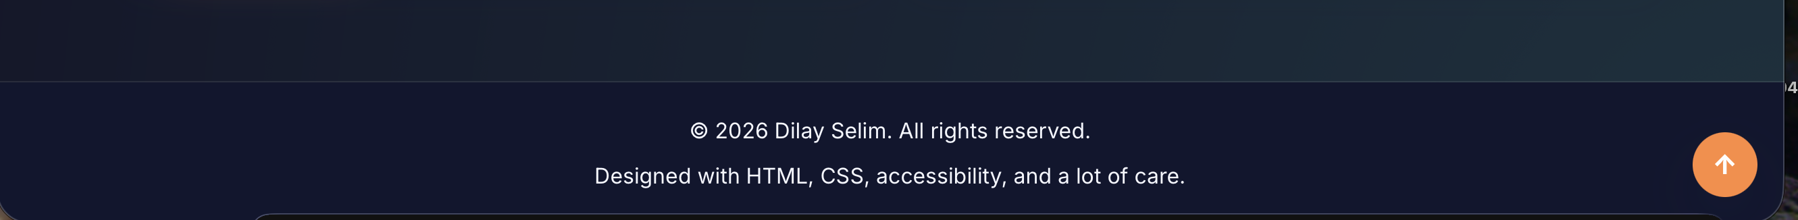

- The footer appears at the bottom of the website and contains copyright information and a short note about the technologies used. This section was created using the <footer> HTML element and styled with CSS for consistent layout.
- Back to Top Button- A floating 'Back to Top' button allows users to quickly return to the top of the page. This was implemented using an anchor link and styled with CSS to stay fixed at the bottom corner of the screen.

8. Technologies Used
This website was built using several web technologies:
- HTML5 for semantic structure
- CSS3 for layout, colors, gradients, and responsiveness
- Flexbox and Grid for positioning elements
- JavaScript for the dark mode toggle feature
- Google Fonts for typography
- Embedded media including YouTube video and HTML5 audio

